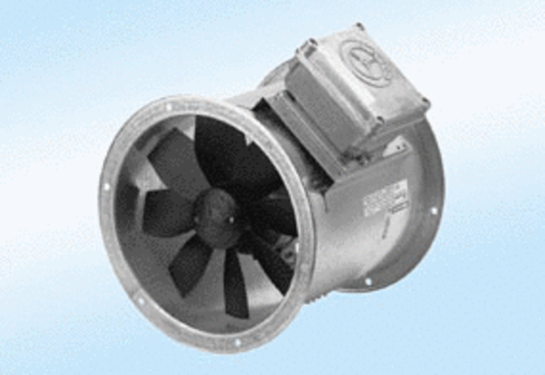Axial duct fan DZR 30/2 A-ExPacking unit: 1 pieceRange: C
Article number: 0086.0767Manufacturer: MAICO

