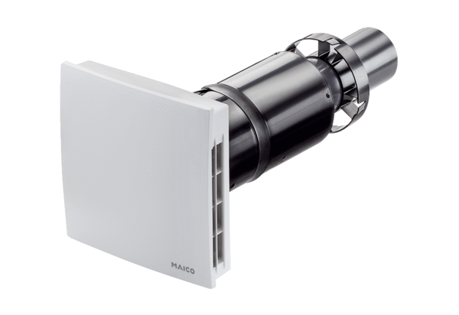Final assembly kit PPB 30 KPacking unit: 1 pieceRange: K
Article number: 0095.0246Manufacturer: MAICO

