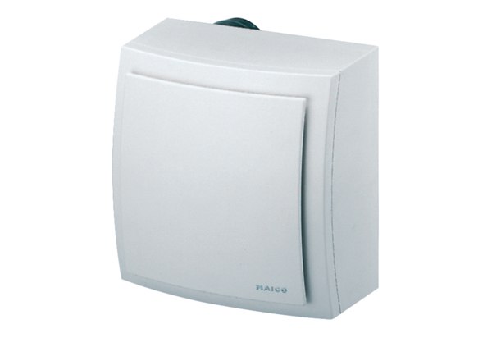Surface-mounted fan ER-AP 60Packing unit: 1 pieceRange: B
Article number: 0084.0150Manufacturer: MAICO

