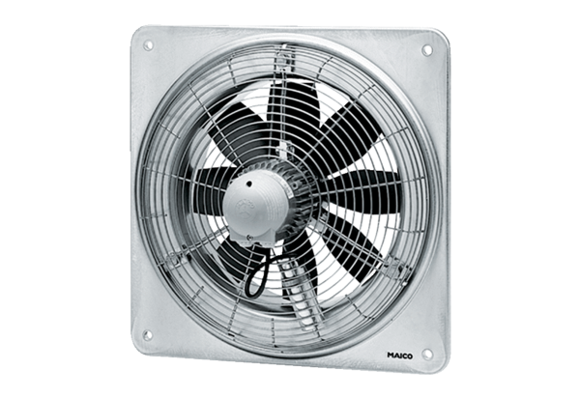Axial wall fan EZQ 45/4 BPacking unit: 1 pieceRange: C
Article number: 0083.0101Manufacturer: MAICO

