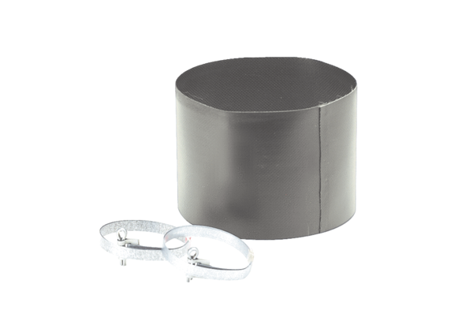Flexible cuff ELM 15Packing unit: 1 pieceRange: C
Article number: 0092.0117Manufacturer: MAICO

