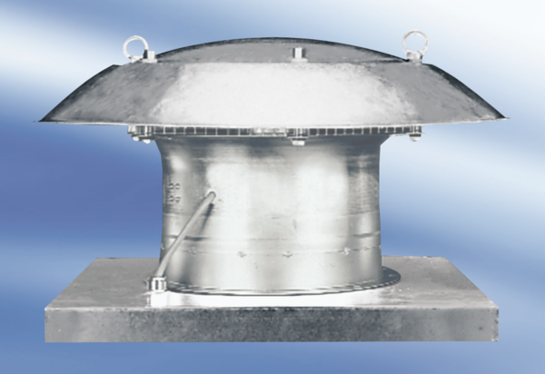Axial roof fan DZD 35/84 APacking unit: 1 pieceRange:
Article number: 0087.0439Manufacturer: MAICO

