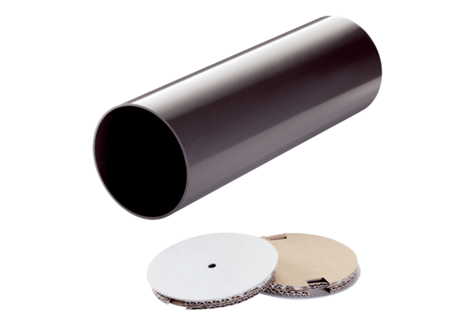Shell sleeve PP 45 RHKPacking unit: 1 pieceRange: K
Article number: 0059.0081Manufacturer: MAICO

