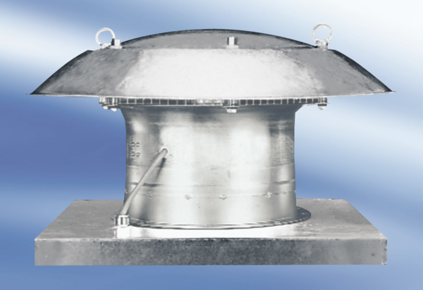Axial roof fan DZD 35/42 APacking unit: 1 pieceRange:
Article number: 0087.0441Manufacturer: MAICO

