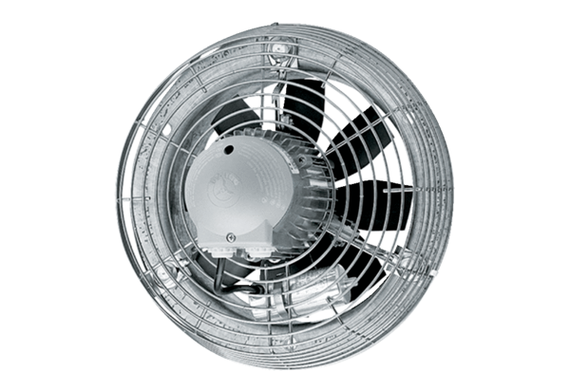Axial wall fan DZS 30/2 BPacking unit: 1 pieceRange: C
Article number: 0094.0016Manufacturer: MAICO

