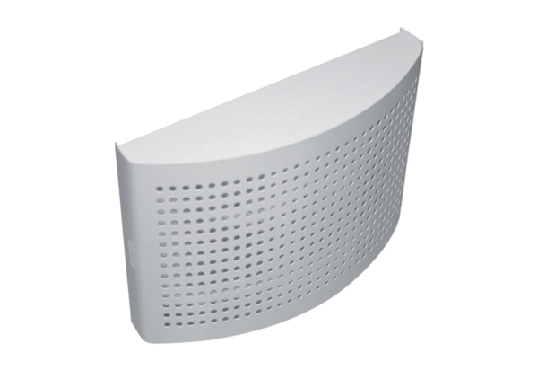Supply air valve ZWVQ 10Packing unit: 1 pieceRange: K
Article number: 0152.0064Manufacturer: MAICO

