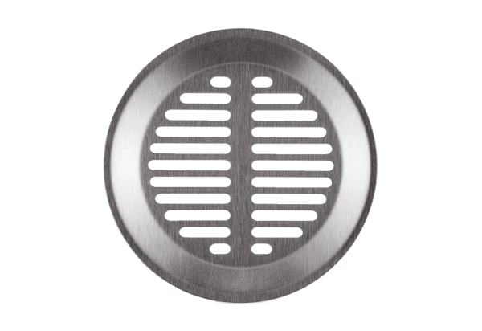Wall/Ceiling grille FFS-WGPacking unit: 1 pieceRange: K
Article number: 0055.0892Manufacturer: MAICO

