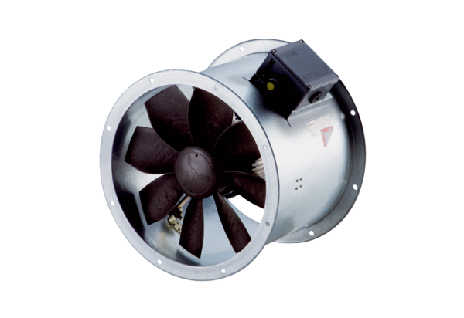Axial duct fan DZR 30/2 B Ex ePacking unit: 1 pieceRange: C
Article number: 0086.0705Manufacturer: MAICO

