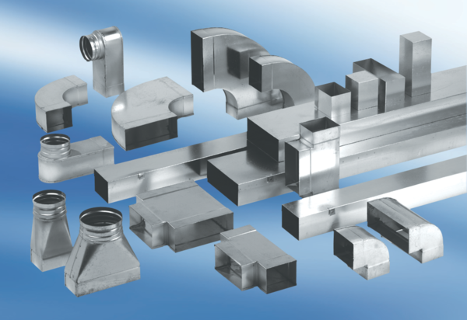45° channel elbows, horizontal KB45H/55/110Packing unit: 1 pieceRange: K
Article number: 0055.0582Manufacturer: MAICO

