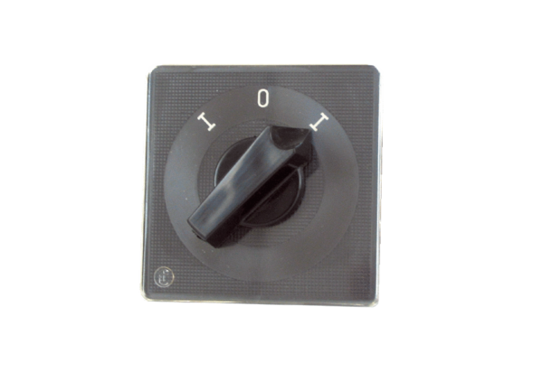Reversing switch WU 1Packing unit: 1 pieceRange: C
Article number: 0157.0102Manufacturer: MAICO

