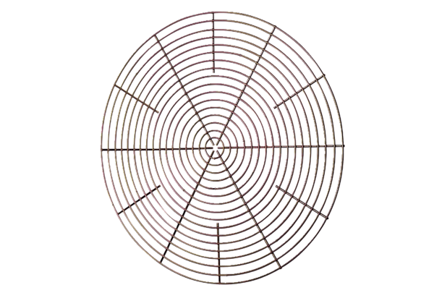Protective grille, metal SG 25Packing unit: 1 pieceRange: C
Article number: 0150.0115Manufacturer: MAICO

