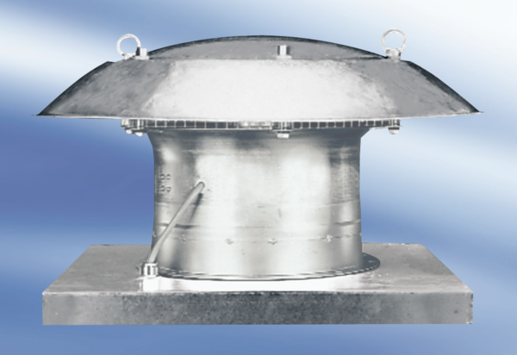Axial roof fan DZD 50/8 APacking unit: 1 pieceRange:
Article number: 0087.0424Manufacturer: MAICO

