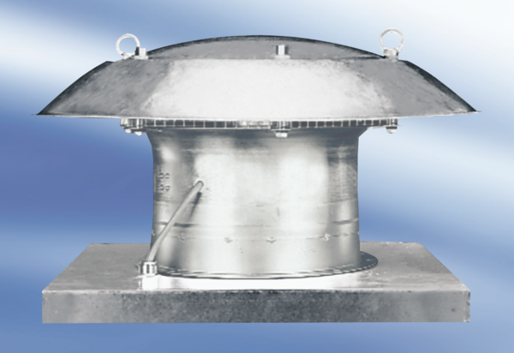Axial roof fan DZD 60/84 APacking unit: 1 pieceRange:
Article number: 0087.0453Manufacturer: MAICO

