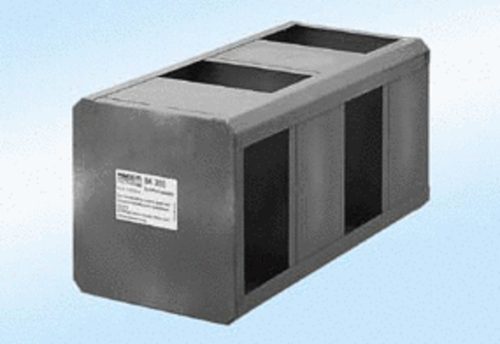Summer cassette SK300Packing unit: 1 pieceRange:
Article number: 0180.0919Manufacturer: MAICO

