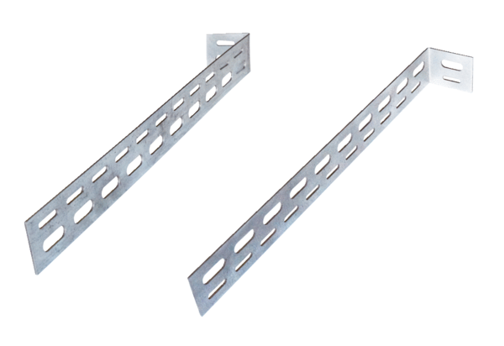Mounting support ER-UPMPacking unit: 1 pieceRange: B
Article number: 0093.0277Manufacturer: MAICO

