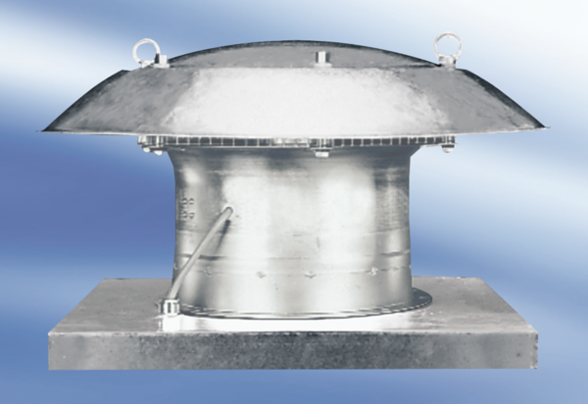Axial roof fan DZD 60/86 APacking unit: 1 pieceRange:
Article number: 0087.0452Manufacturer: MAICO

