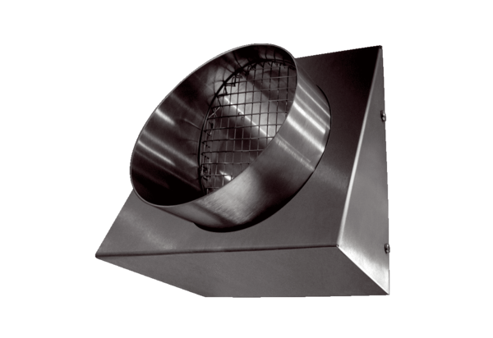Outgoing air wall connection KW-FL 12EPacking unit: 1 pieceRange: K
Article number: 0152.0075Manufacturer: MAICO

