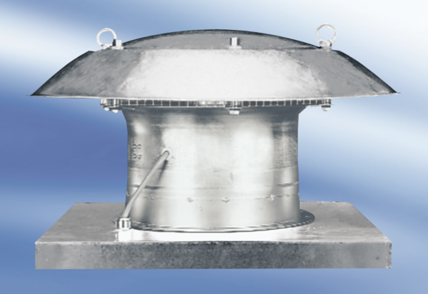Axial roof fan DZD 35/2 APacking unit: 1 pieceRange:
Article number: 0087.0419Manufacturer: MAICO

