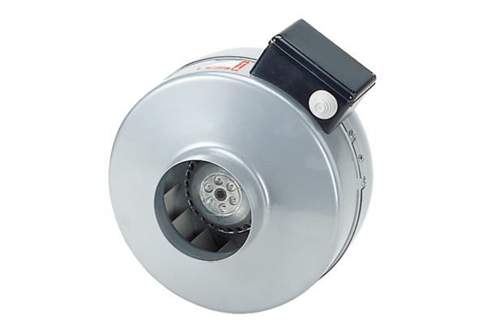Centrifugal duct fan ERR 16/1Packing unit: 1 pieceRange: C
Article number: 0080.0273Manufacturer: MAICO

