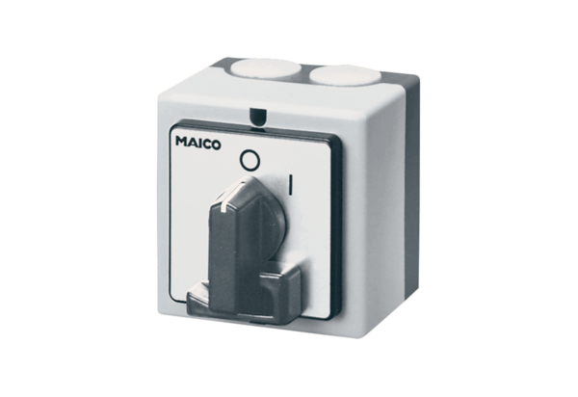Main switch, service switch HS 3Packing unit: 1 pieceRange: C
Article number: 0157.0736Manufacturer: MAICO

