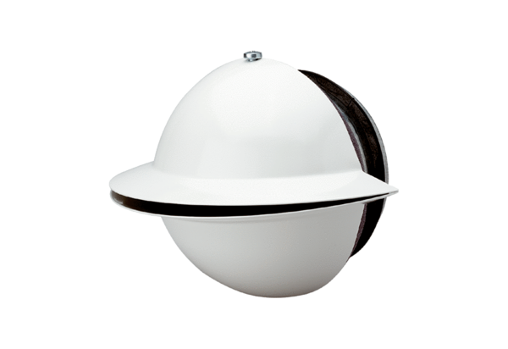Blower nozzle WD 10 WPacking unit: 1 pieceRange: K
Article number: 0151.0290Manufacturer: MAICO

