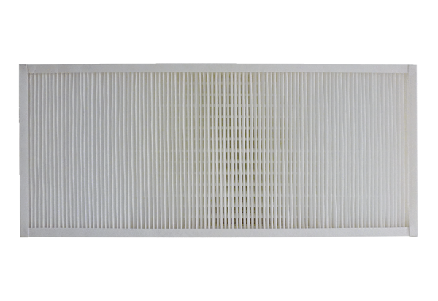Air filter, replacement KFF 9030-5Packing unit: 1 pieceRange: K
Article number: 0093.1216Manufacturer: MAICO

