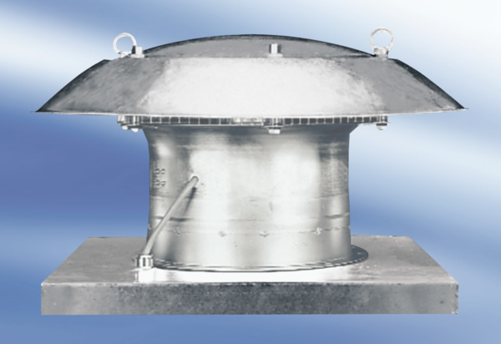Axial roof fan EZD 50/8 APacking unit: 1 pieceRange:
Article number: 0087.0410Manufacturer: MAICO

