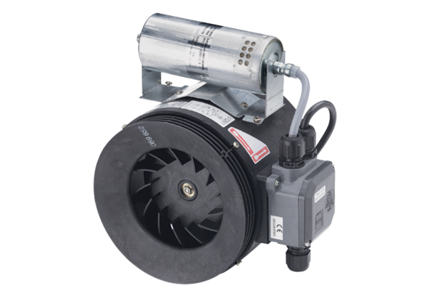Semi-centrifugal duct fan ERM 22 Ex ePacking unit: 1 pieceRange: C
Article number: 0080.0288Manufacturer: MAICO

