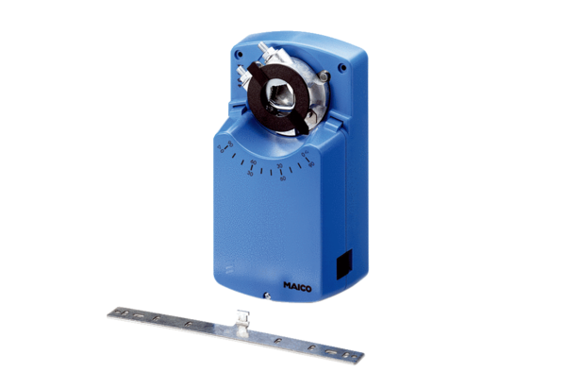Servomotor MS 8Packing unit: 1 pieceRange: C
Article number: 0157.0760Manufacturer: MAICO

