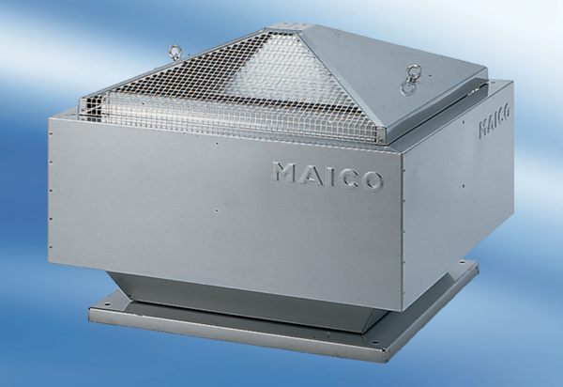Centrifugal roof fan DRD 63/86Packing unit: 1 pieceRange: C
Article number: 0087.0159Manufacturer: MAICO

