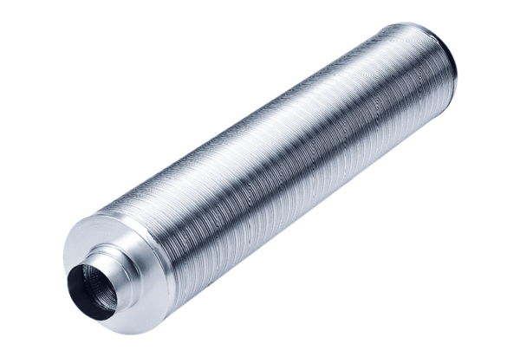Tubular sound absorber RSR 10/50Packing unit: 1 pieceRange: C
Article number: 0092.0321Manufacturer: MAICO

