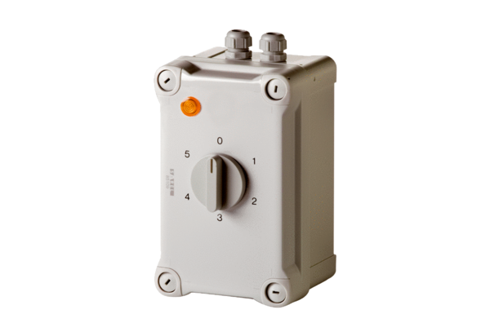5-step transformer TRE 6,5-1Packing unit: 1 pieceRange: C
Article number: 0157.0842Manufacturer: MAICO

