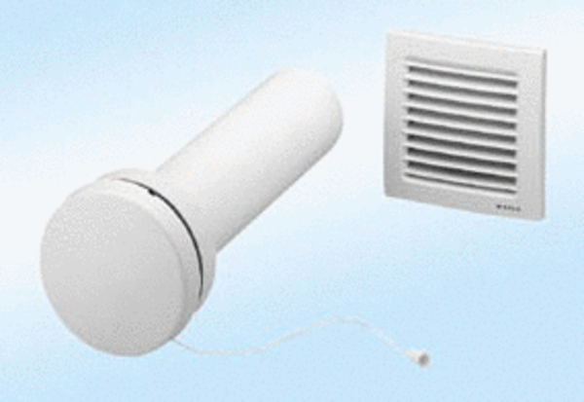Supply air element, uncontrolled ZE10-IZPacking unit: 1 pieceRange:
Article number: 0152.0035Manufacturer: MAICO

