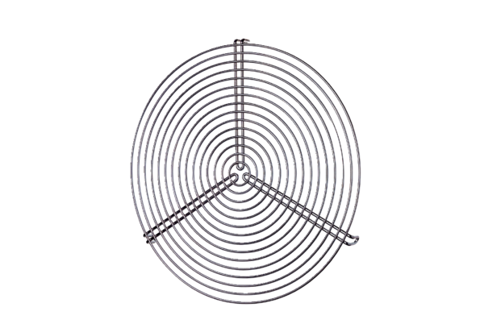Protective grille SGR 25Packing unit: 1 pieceRange: C
Article number: 0150.0127Manufacturer: MAICO

