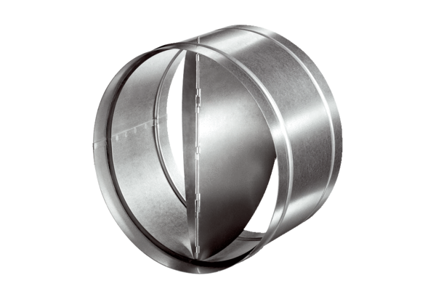Automatic backflow preventer AVM 40Packing unit: 1 pieceRange: C
Article number: 0093.0013Manufacturer: MAICO

