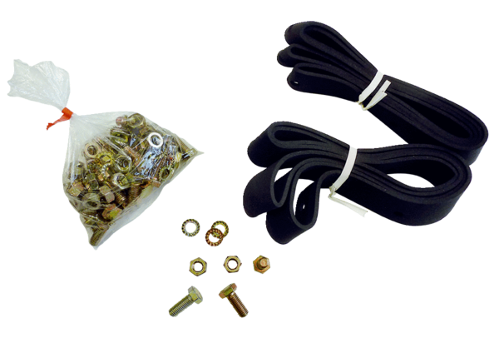Mounting and sealing material BD 30Packing unit: 1 pieceRange: C
Article number: 0092.0134Manufacturer: MAICO

