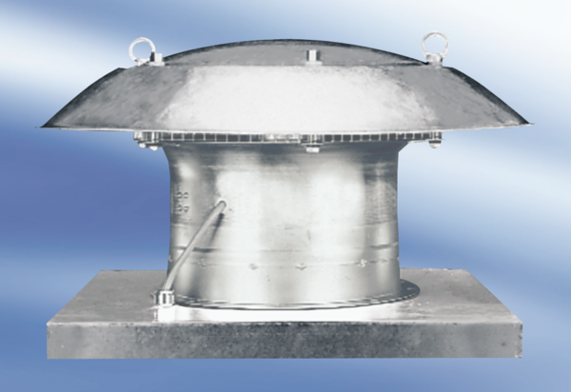Axial roof fan DZD 35/2 A-ExPacking unit: 1 pieceRange: C
Article number: 0087.0772Manufacturer: MAICO

