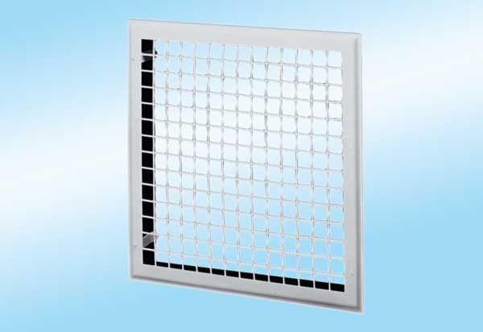Internal grille MLG 40Packing unit: 1 pieceRange: C
Article number: 0151.0065Manufacturer: MAICO

