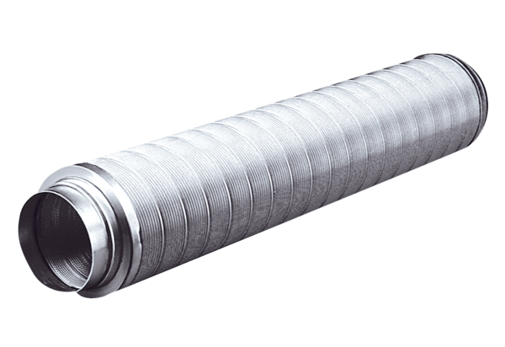Tubular sound absorber RSR 12Packing unit: 1 pieceRange: C
Article number: 0092.0312Manufacturer: MAICO

