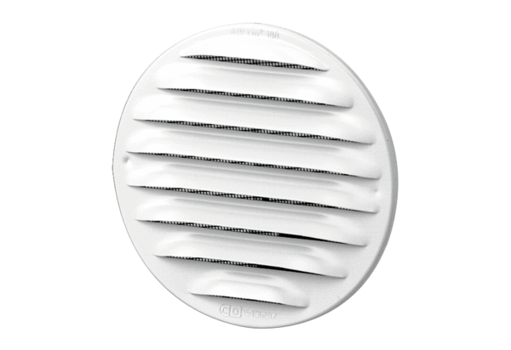External grille MGR 80/125 whitePacking unit: 1 pieceRange: K
Article number: 0078.0070Manufacturer: MAICO

