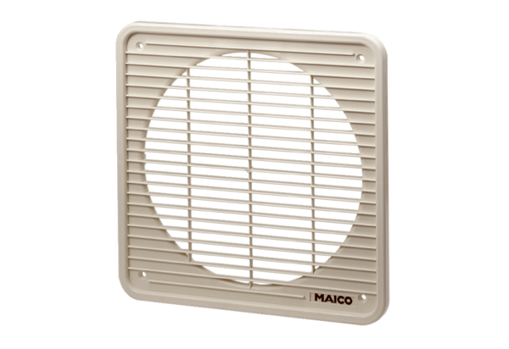Internal grille IG 30Packing unit: 1 pieceRange: C
Article number: 0059.0173Manufacturer: MAICO

