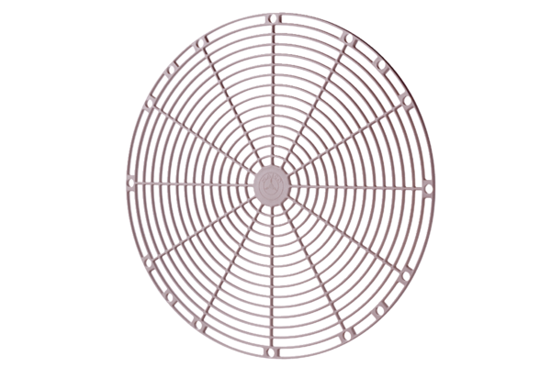Protective grille, synthetic material SGK 20Packing unit: 1 pieceRange: C
Article number: 0059.0161Manufacturer: MAICO

