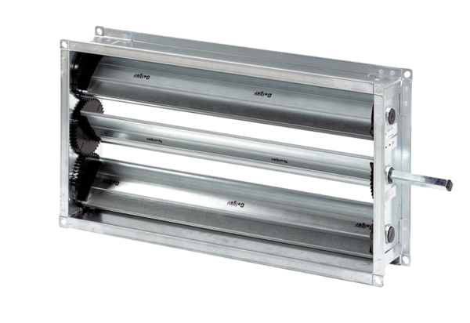Channel shutter RKP 56Packing unit: 1 pieceRange: D
Article number: 0151.0241Manufacturer: MAICO

