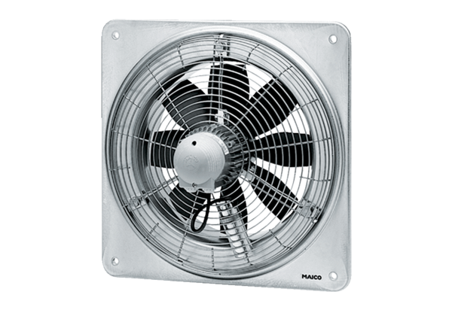Axial wall fan EZQ 35/6 BPacking unit: 1 pieceRange: C
Article number: 0083.0108Manufacturer: MAICO

