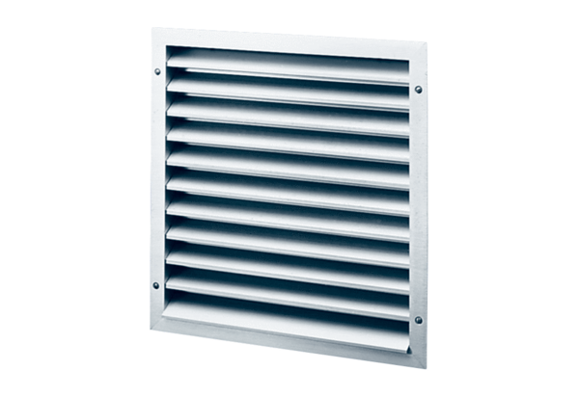External grille MLZ 20Packing unit: 1 pieceRange: C
Article number: 0151.0101Manufacturer: MAICO

