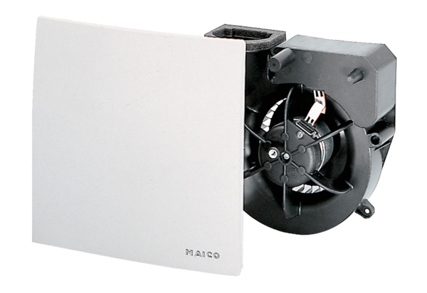Fan insert ER 100 VZ 15Packing unit: 1 pieceRange: B
Article number: 0084.0140Manufacturer: MAICO

