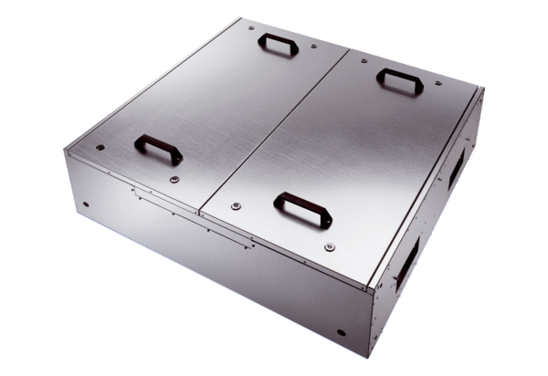Sound-insulated ventilation box KFR 9030-KPacking unit: 1 pieceRange: K
Article number: 0080.0967Manufacturer: MAICO

