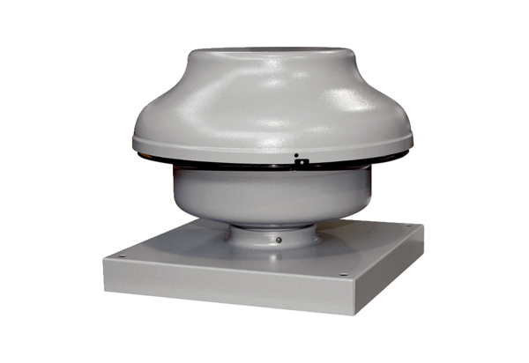Centrifugal roof fan EHD 16Packing unit: 1 pieceRange: C
Article number: 0087.0303Manufacturer: MAICO

