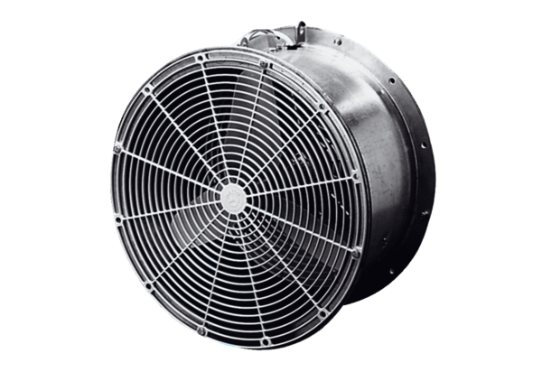Greenhouse fan EFG 30 EPacking unit: 1 pieceRange: C
Article number: 0081.0403Manufacturer: MAICO

