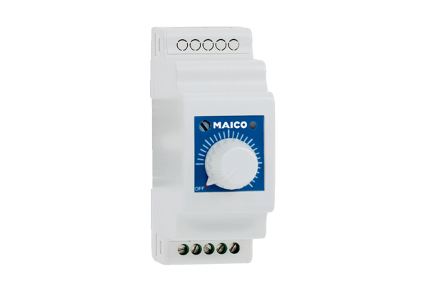Speed controller, distribution board STSX 2,5Packing unit: 1 pieceRange: C
Article number: 0157.1564Manufacturer: MAICO

